## **requirements for the application:**

* The application should be done using *Spring Boot*
* The system should be able to *create* and *display* movies.
* A user should be able to search for movies on relevant based on the title.
* The application should be done using *Git* and should be handed in on *GitHub* with a link to your repository on *Fronter*.
  + You should work with a *master* branch and each group member should during the project at least once:
    - create a *feature* branch,
    - create the feature,
    - and merge it into the master branch.
  + The feature should be a *Use Case* or part of a *Use Case*.
* You should document the analysis and design flow in Use Cases and by using the UML diagrams you worked with in 1. semester.
* You should make use of at least 3 *GRASP* design principles in your application.

Actors: user, system

Brief Use case 1: display movies

Main success scenario: a user enters localhost/8080 in browser and a site with movies turns up. Where all movies in the system will be push up.

Brief Use case 2: create movie

Main success scenario: a user wants to add a new movie to the movies list. The user uses the button create and the system then takes the user to a new website where he/she will fill out the empty forms(title, year,genre, duration), after the info has been written the user push the button create and the system sends the user back to the movie list site with a new movie added.

Brief Use case 3: search movie

Main success scenario: the user search on a movie title in the search bar, the system finds the title equantlant in its current movies on the movie list.

Noun list:

User

Movie

Title

Year

Genre

Duration

Button

Bar

System

Website

List

Use case diagram:

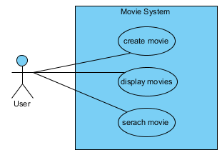

Domain model:

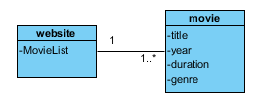

System sequence diagrams:

Sequence diagrams:

Use case 1

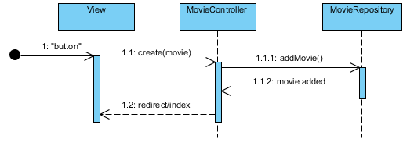

Use case 2

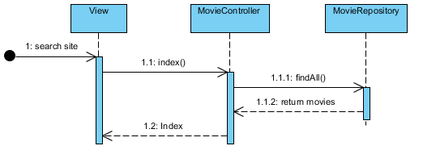

Use case 3

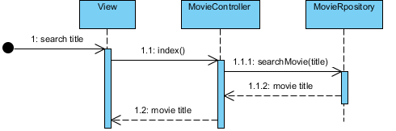

3 Grasp:

Vi har andvendet Creator, low coupling, high cohesion som vores patterns til at lave vores class diagram.

Class diagram:

